TEACHING WITH ARTIFICIAL INTELLIGENCE · GRAPHIC
The Safety Gap — reusable graphic

A two-bar graphic for slides, a syllabus discussion, or a department conversation. The image and its alt text are below; color is paired with text and a hatch pattern, so no meaning depends on color alone.
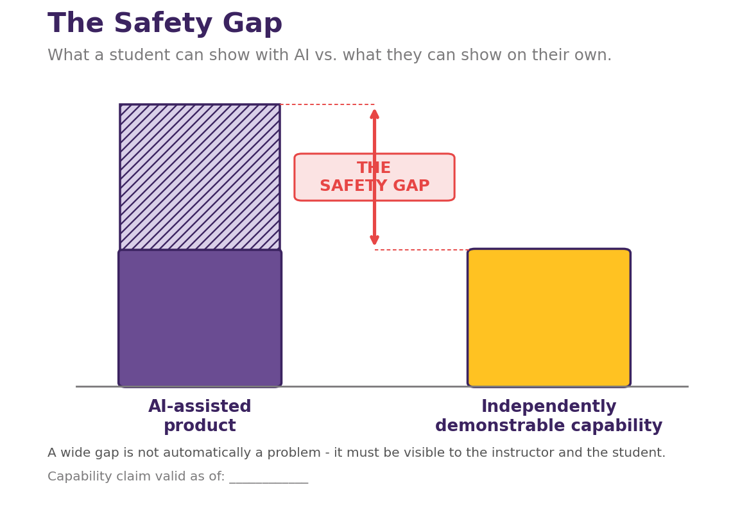
Caption: A wide gap is not automatically a problem — it must be visible to the instructor and the student.

Alt text (for accessibility)
A two-bar comparison graphic titled “The Safety Gap.” The left bar, “AI-assisted product,” is tall. The right bar, “Independently demonstrable capability,” is much shorter — a little under half the height of the left bar. A red double-headed arrow runs in the gutter between the two bars, connecting the height of the short right bar to the height of the tall left bar; a red box on that arrow labels the distance “THE SAFETY GAP.” The portion of the left bar that rises above the height of the right bar is shaded lighter and hatched to mark it as the gap.
Meaning: the Safety Gap is the distance between what a student can produce with AI assistance and what they can independently demonstrate. A wide gap is not automatically a misconduct problem — it may reflect appropriate scaffolding — but it must be visible to both the instructor and the student.

